**Microorganism as producer of organic nitrogen fertilizer**

* **Overview and** **potential of cyanobacteria nitrogen fixation**
* **Potential requirement for cyanobacteria survival**
* **Mechanism of cyanobacteria fertilizer production**
* **Current approaches and techniques for cyanobacterial use as fertilizer**

**Overview and potential of cyanobacteria nitrogen fixation**

Cyanobacteria, also known as blue green algae, are a diverse group of gram-negative photosynthetic prokaryotes. Cyanobacteria are divided into give groups as shown in table 1.

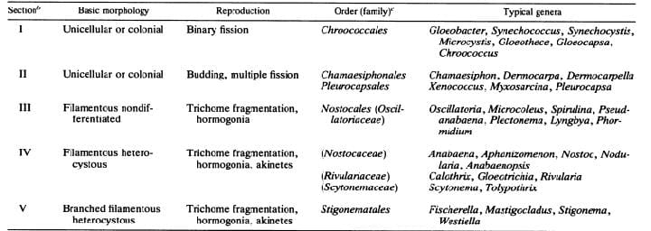**Table 1. principle group of cyanobacteria**

Photosynthetic energy conversion in the cyanobacteria is similar to that in eukaryotic algae and in green plants. It involves the operation of two distinct photosystems, photosystem I and photosystem II (PS I and PS II, respectively), which are linked in series and interact through a chain of electron carriers.

Cyanobacteria are common in a great variety of natural habitats and are often abundant in fresh water and seawater, as well as in terrestrial environments (100). A few genera of heterocystous cyanobacteria are engaged in specific symbiotic associations with algae, fungi, liverworts, ferns, and higher plants. In all these associations the endosymbiotic cyanobacteria become extensively modified in their appearance, biochemical properties, and metabolic activities, which results in extremely high rates of nitrogen fixation and in the transfer of the bulk of the fixed nitrogen to the host organism.

Many cyanobacteria also contribute greatly to the nitrogen economy of aquatic and terrestrial habitats through their one, thus enabling the development of the aerobic mode of ability to fix atmospheric nitrogen.

The concept of a common origin of nitrogen fixation is consistent with the strikingly similar physical and chemical characteristics of the nitrogen-fixing enzyme system present in otherwise dissimilar organisms. The enzyme complex consists of two component proteins. One is a Mo-Fe protein, called dinitrogenase, and the other is an Fe-containing protein, dinitrogenase reductase. Dinitrogenase is a tetramer composed of two pairs of different subunits, it contains four (4Fe-4S) clusters and two molecules of Mo-Fe cofactor. The Mo-Fe cofactor is an essential component of dinitrogenase; it contains eight Fe and six S atoms per Mo atom, without forming 4Fe-4S clusters. The molecular mass of dinitrogenase is about 245 kDa. Dinitrogenase reductase is a dimer composed of two identical subunits with a single (4Fe-4S) cluster and a molecular mass of about 64 kDa. The Mo-Fe cofactor is thought to effect the binding and reduction of dinitrogen to ammonia:

N2 + 6H+ + 6e - 2NH3

Electrons for the reduction of N2 are supplied by dinitrogenase reductase. The reaction is highly endergonic, requiring about 12 to 15 mol of ATP per mol of N2 reduced.

Ammonia, the product of nitrogen fixation, is assimilated mainly via the glutamine synthetase-glutamate synthase pathway, in the same way as exogenously supplied ammonia. Other enzymes, such as alanine dehydrogenase and glutamate dehydrogenase, may have a minor role in ammonia incorporation. In some nitrogen-fixing organisms the supply of ammonia may rapidly inhibit nitrogenase activity. This reversible inhibition by ammonia is attributed to a modification of one subunit of nitrogenase reductase.

**Potential requirement for cyanobacteria survival**

**Effect of oxygen on nitrogen fixation**

**Effect of seasons on nitrogen fixation**